# Software Requirement Specifications

## Design Overview

This document describes the technical and user interface design of FFRS System. It includes the architectural design, the detailed design of common functions and business functions and the design of database model.

* The architectural design describes the overall architecture of the system and the architecture of each main component and subsystem.
* The detailed design describes static and dynamic structure for each component and functions. It includes class diagram, class explanations and sequence diagrams for each use cases.
* The database design describes the relationships between entities and details of each entity.
* Document overview:
  + Section 2: gives an overall description of the system architecture design.
  + Section 3: gives component diagrams that describes the connection and integration of the system.
  + Section 4: gives the detail design description which includes class diagram, class explanation and sequence diagram to details the application functions.
  + Section 5: describes screen design.
  + Section 6: describes a fully attributed ERD.
  + Section 7: describes algorithms.

## System Architectural Design

### System Architecture Design

We choose Restful Web Service model as main model because of following advantages:

* + In the future, our application may expand for other platforms as well. Web service provides reusable API that can be called by any platforms, so that our system could easily expand.
  + Beacon is a newly developed technology; its SDK is changing frequently. When does, we only need to update mobile application without affecting other components.

Web Service is developed from Spring MVC architecture style beacause:

* + It provides comprehensive infrastructure support for developing Java enterprise level applications. Spring also enables the developer to create high performing, easily testable, reusable and loose coupling enterprise Java application.
  + Spring enables the developers to develop the enterprise applications using POJOs (Plain Old Java Object). The benefit of developing the applications using POJO is, that we do not need an enterprise container such as an application server, but we have the option of using a robust servlet container.
  + Spring provides a very clean division between controllers and JavaBean models.

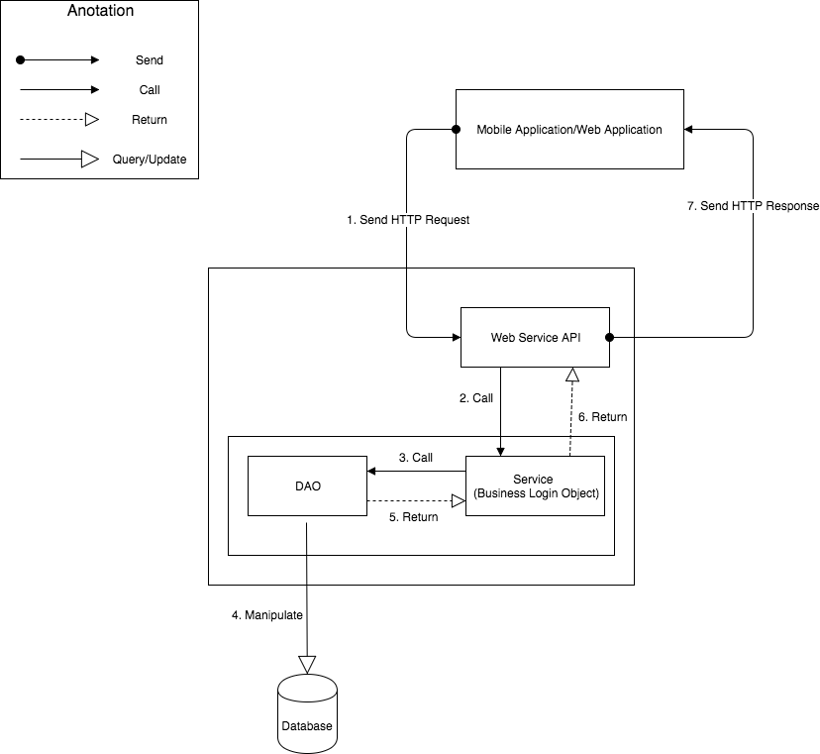

**Figure 1 - System Architecture Design**

### Mobile Application Architecture Design

The application is developed as an Android native application. In general, the application architecture conforms to Android architecture.

*Reference: Android Developer Guider – Application Fundamentals*

[*http://developer.android.com/guide/components/fundamentals.html*](http://developer.android.com/guide/components/fundamentals.html)

Our team chooses Android because of following reasons:

* + Android is currently the most common mobile platforms in the world, and it doesn’t have any signs of slowing down. As we want to maximize our potential users, choosing Android will give us the highest popularity market.
  + Developing other mobile platforms (such as iOS or Windows Phone) may require specific expensive devices and tools. On the other hand, Android development can be done on either Mac, Windows or Linux devices with free tools.
  + Native Android applications are developed using Java programing language. Our team is strong at Java and chooses it as the main programing language.

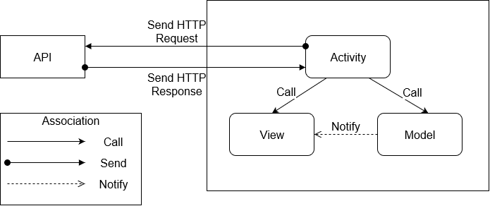

**Figure 1 – Mobile Application Architecture Design**

### Web Application Architecture Design

* + In general, use Redux when you have reasonable amounts of data changing over time, you need a single source of truth, and you find that approaches like keeping everything in a top-level React component's state are no longer sufficient.
* However, it's also important to understand that using Redux comes with tradeoffs. It's not designed to be the shortest or fastest way to write code. It's intended to help answer the question "When did a certain slice of state change, and where did the data come from?", with predictable behavior. It does so by asking you to follow specific constraints in your application: store your application's state as plain data, describe changes as plain objects, and handle those changes with pure functions that apply updates immutably. This is often the source of complaints about "boilerplate". These constraints require effort on the part of a developer, but also open up a number of additional possibilities (such as store persistence and synchronization).
  + In the end, Redux is just a tool. It's a great tool, and there's some great reasons to use it, but there's also reasons you might not want to use it. Make informed decisions about your tools, and understand the tradeoffs involved in each decision.

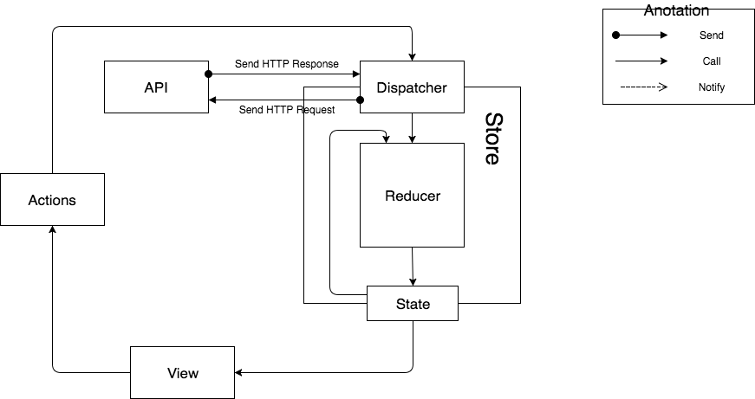

Figure 2 – Web Application Architecture Design

## Component Diagram

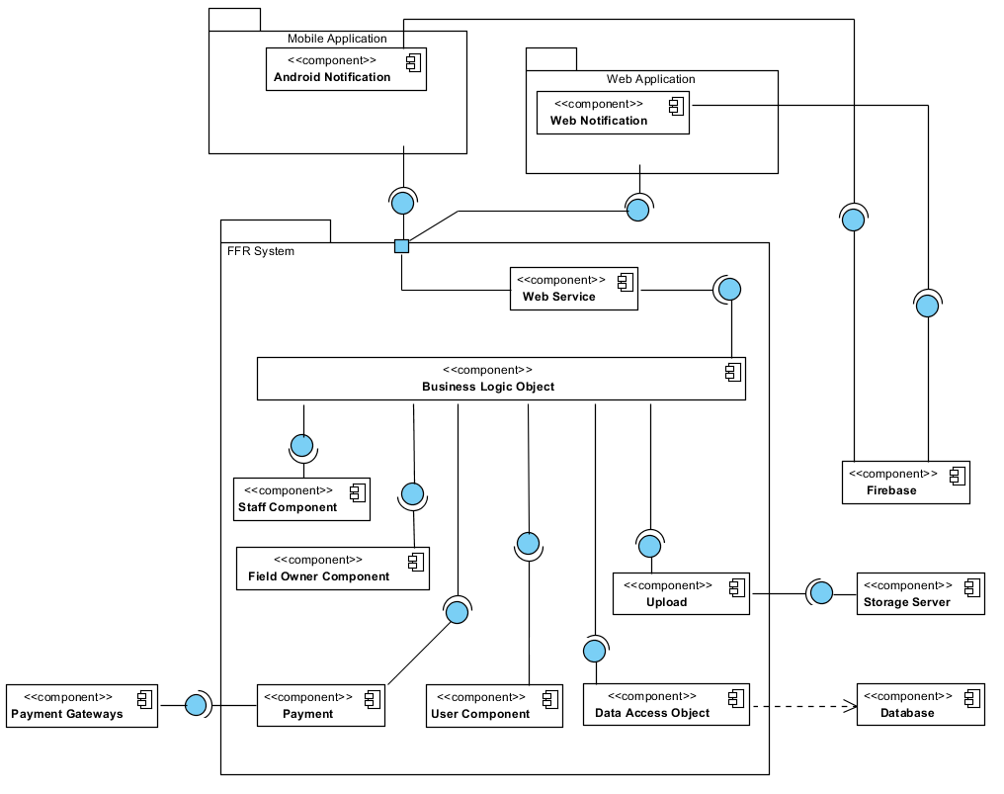

**Figure 10: Component Diagram**

|  |  |
| --- | --- |
| Component Dictionary: Describes components | |
| Business Logic Object | Common objects handle domain business operations for each component. |
| User Component | Component handles user activities in the system. |
| Field Owner Component | Component handles field owner activities in the system. |
| Staff Component | Component handles staff activities in the system. |
| Web Service | Provide API for mobile application and web application to interact with the system. |
| Upload | Component handles upload file to storage server. |
| Data Access Object | Component interacts between the system and database. |
| Payment | Component to interacts between the system and payment gateways. |
| FFR System | FFR System package: back-end system. |
| Payment Gateways | Payment Gateways: Paypal, Nganluong. |
| Database | Component represents for MySQL Database. |
| Storage Server | Component saves information: image avatar. |
| Firebase | Component supports notification between Android Application and Web Application. |
| Android Application | Android Application package. |
| Web Application | Web Application package: View, Controller. |
| Android Notification | Component supports android application to receive notifications. |
| Web Notification | Component supports web application to receive notifications. |

## Detailed Description

### Class Diagram

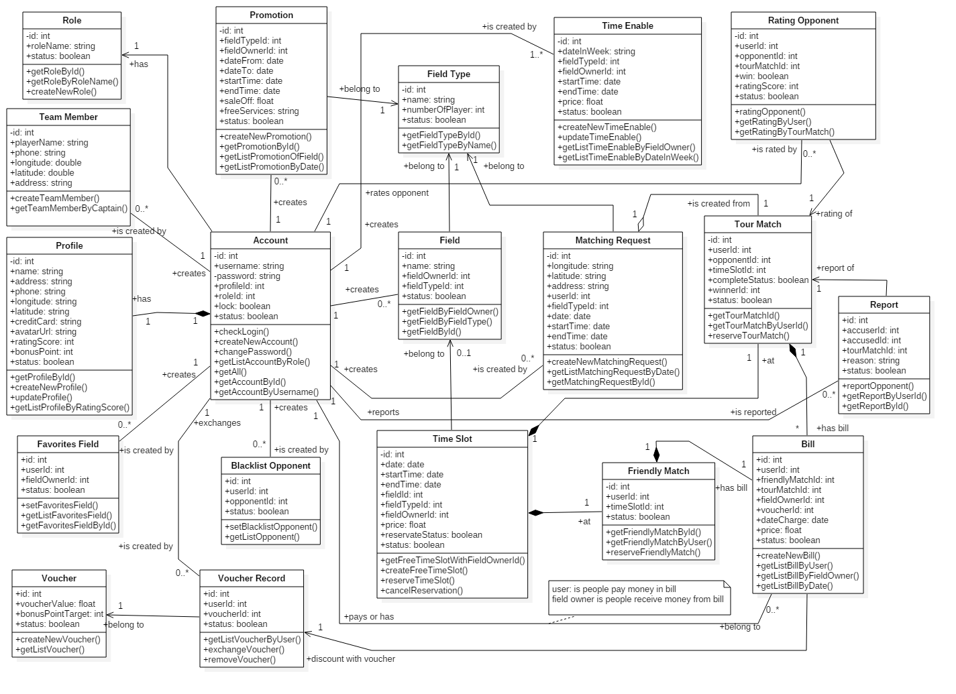

### Class Diagram Explanation

#### Account

#### Profile

### Interaction Diagram

#### Sequence Diagram

#### Activity Diagram

## User Interface Design

### Mobile Application

#### Login

1. 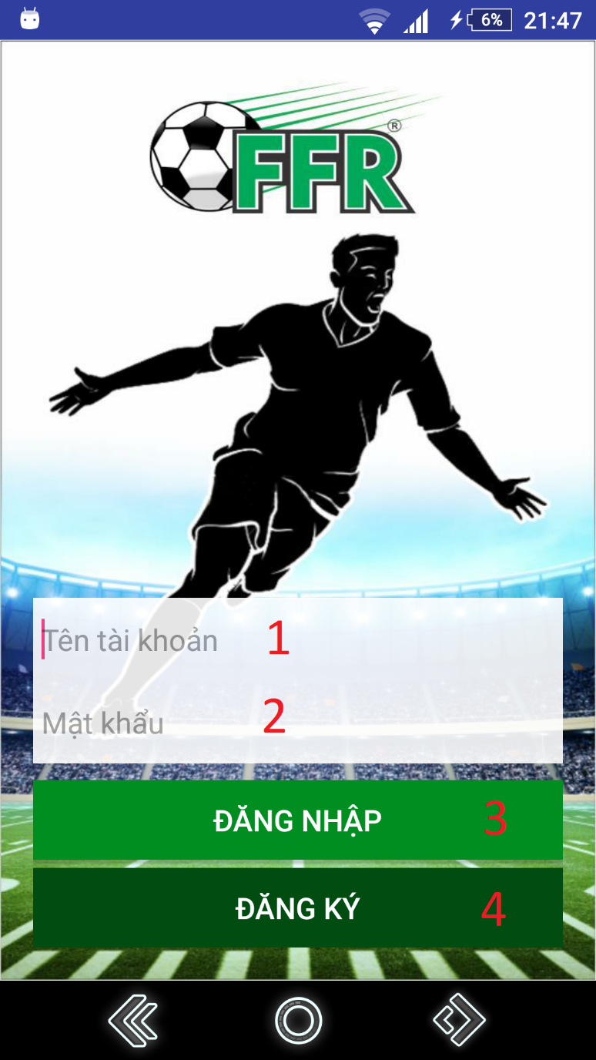
2. **Figure 99 - Login UI**
3. **Fields:**

|  |  |  |  |  |  |  |
| --- | --- | --- | --- | --- | --- | --- |
| **No** | **Field Names** | **Description** | **Read Only** | **Mandatory** | **Control Type** | **Data Type** |
| 1 | Username | Fill username | No | Yes | EditText | String |
| 2 | Password | Fill password | No | Yes | Password | String |

**Table 55 - <Mobile Application> Login Fields**

1. **Buttons/Hyperlinks**

|  |  |  |  |  |
| --- | --- | --- | --- | --- |
| **No** | **Function** | **Description** | **Validation** | **Outcome** |
| 3 | login | Login with username and password | N/A | Redirect to search field view |
| 4 | register | Create new account | N/A | Redirect to register view |

**Table 56 - <Mobile Application> Login Buttons/Hyperlinks**

#### 5.1.2 Register

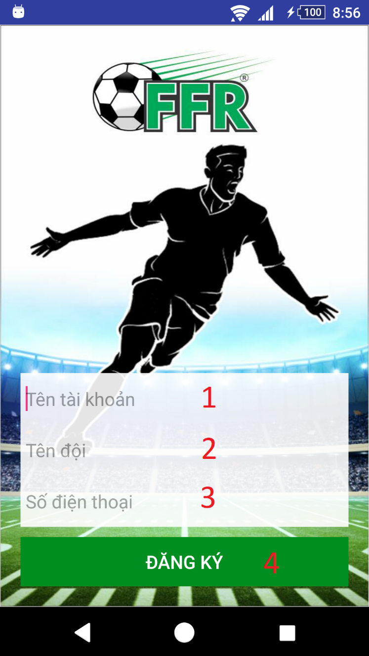

**Figure 100 - Register UI**

**Fields**

|  |  |  |  |  |  |  |
| --- | --- | --- | --- | --- | --- | --- |
| **No** | **Field Names** | **Description** | **Read Only** | **Mandatory** | **Control Type** | **Data Type** |
| 1 | username | Fill username | No | Yes | EditText | String |
| 2 | teamName | Fill user’s team name | No | Yes | EditText | String |
| 3 | phone | Fill phone | No | Yes | EditText | String |

**Table 57 - <Mobile Application> Register Fields**

**Buttons/Hyperlinks**

|  |  |  |  |  |
| --- | --- | --- | --- | --- |
| **No** | **Function** | **Description** | **Validation** | **Outcome** |
| 4 | register | Create new account | All fields required before summit | Redirect to search field view. |

**Table 58 - <Mobile Application> Register Buttons/Hyperlinks**

#### 5.1.3 Menu

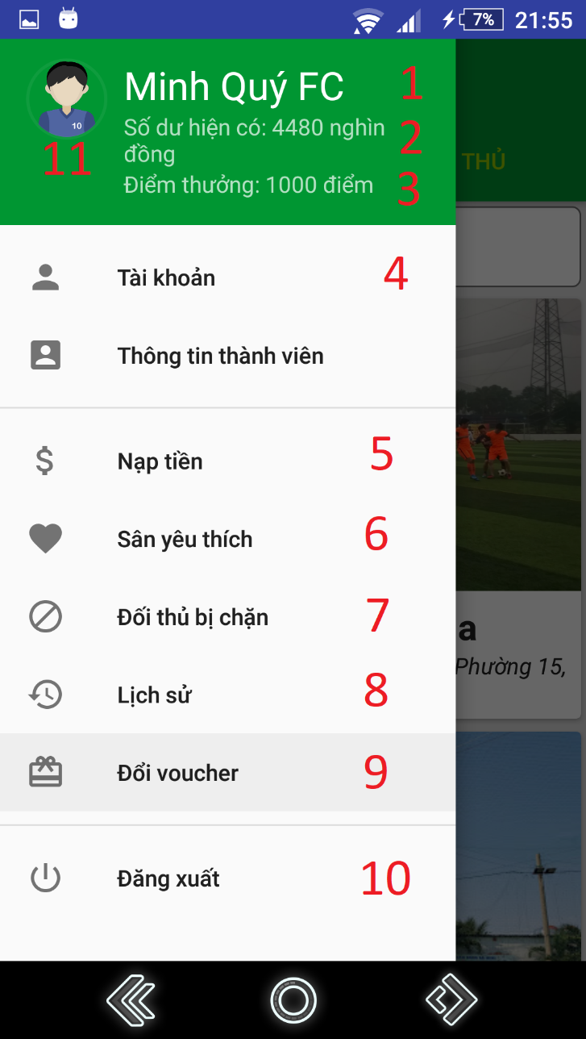

**Figure 101 - Menu UI**

**Fields**

|  |  |  |  |  |  |  |
| --- | --- | --- | --- | --- | --- | --- |
| **No** | **Field Names** | **Description** | **Read Only** | **Mandatory** | **Control Type** | **Data Type** |
| 1 | name | User’s team name | Yes | Yes | TextView | String |
| 2 | balance | User’s current balance | Yes | Yes | TextView | String |
| 3 | bonusPoint | User’s current bonus point | Yes | Yes | TextView | String |
| 11 | avatar | User’s avatar | Yes | Yes | Image | N/A |

**Table 59 - <Mobile Application> Menu Fields**

**Buttons/Hyperlinks**

|  |  |  |  |  |
| --- | --- | --- | --- | --- |
| **No** | **Function** | **Description** | **Validation** | **Outcome** |
| 4 | viewProfile | View user’s profile | N/A | Redirect to view profile view. |
| 5 | recharge | Go to recharge view | N/A | Redirect to recharge view. |
| 6 | viewFavoriteField | Show current area of user | N/A | Redirect to view location view. |
| 7 | viewBlacklist | Show user’s current blacklist | N/A | Redirect to view blacklist view. |
| 8 | viewHistory | Show user’s history | N/A | Redirect to view history view. |
| 9 | viewVoucher | Show available vouchers. | N/A | Redirect to view vouchers view. |
| 10 | logout | Logout of system | N/A | Redirect to login view. |

**Table 60 - <Mobile Application> Menu Buttons/Hyperlinks**

#### 5.1.4 Search Field

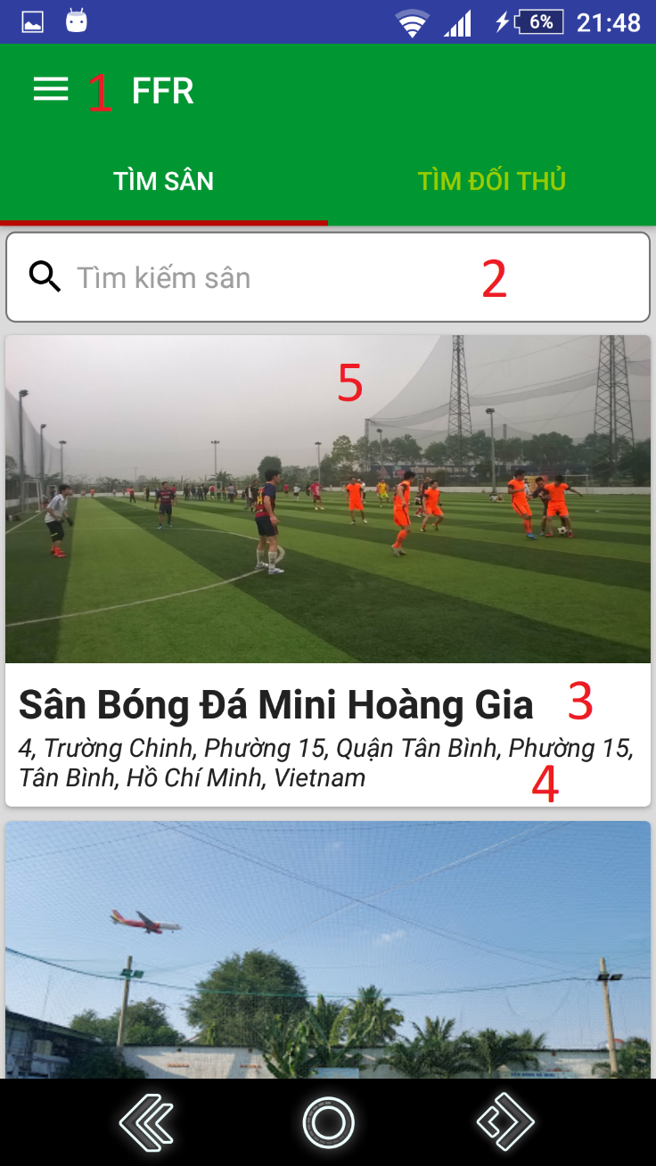

**Figure 102 – Search Field UI**

**Fields**

|  |  |  |  |  |  |  |
| --- | --- | --- | --- | --- | --- | --- |
| **No** | **Field Names** | **Description** | **Read Only** | **Mandatory** | **Control Type** | **Data Type** |
| 2 | searchText | Input search field name | No | No | EditText | String |
| 3 | fieldName | Field’s name | Yes | No | TextView | String |
| 4 | address | Address | Yes | No | TextView | String |
| 5 | image | Field’s image | Yes | No | ImageView | N/A |

**Table 61 - <Mobile Application> Search Field’s Fields**

**Buttons/Hyperlinks**

|  |  |  |  |  |
| --- | --- | --- | --- | --- |
| **No** | **Function** | **Description** | **Validation** | **Outcome** |
| 1 | showNavigation | Show navigation view | N/A | Show navigation bar |

**Table 62 -<Mobile Application> Search Field Buttons/Hyperlinks**

#### 5.1.5 Choose field’s free time

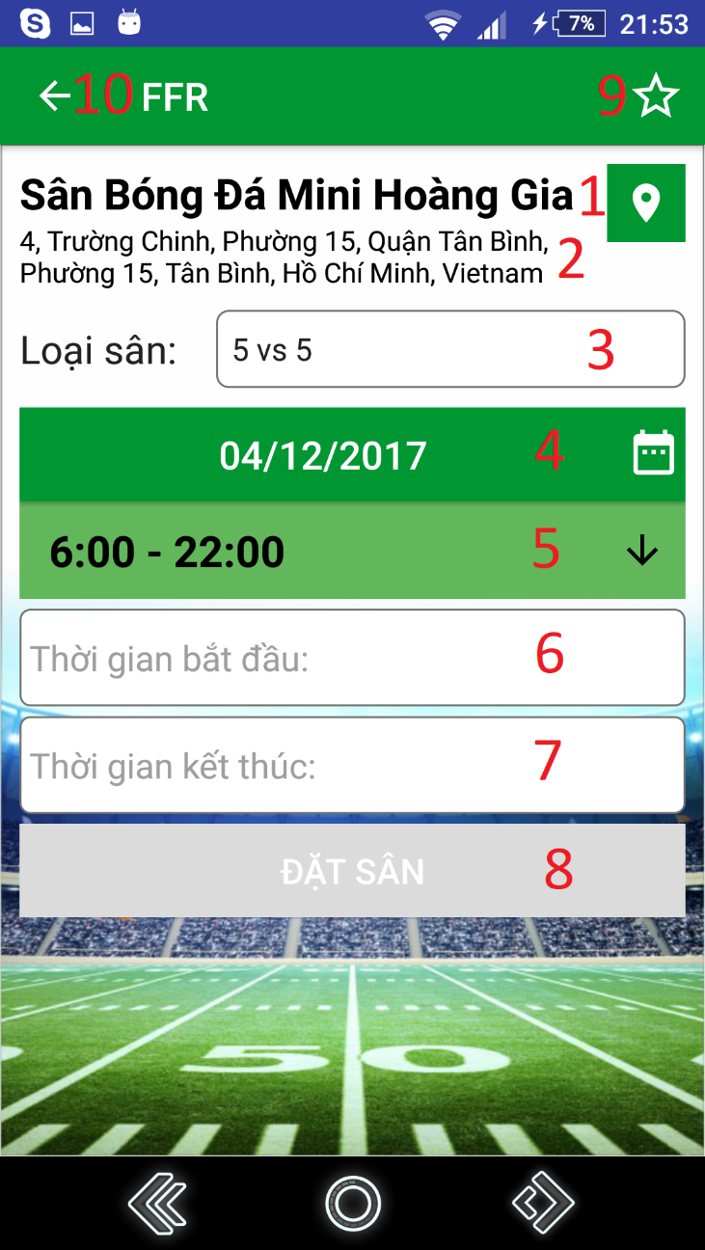

**Figure 103 - Choose field’s free time UI**

**Fields**

|  |  |  |  |  |  |  |
| --- | --- | --- | --- | --- | --- | --- |
| **No** | **Field Names** | **Description** | **Read Only** | **Mandatory** | **Control Type** | **Data Type** |
| 1 | fieldName | Field’s name | Yes | Yes | TextView | String |
| 2 | fieldAddress | Field’s address | Yes | Yes | TextView | String |
| 3 | date | Choose date to reserve | No | Yes | DatePicker | String |
| 4 | fieldType | Field’s type | No | Yes | Dropdown box | String |
| 5 | timeFrame | Time frame | Yes | Yes | TextView | String |
| 6 | startTime | Input start time of reservation | No | Yes | EditText | String |
| 7 | endTime | Input end time of reservation | No | Yes | EditText | String |

**Table 63 - <Mobile Application> Choose field’s free time Fields**

**Buttons/Hyperlinks**

|  |  |  |  |  |
| --- | --- | --- | --- | --- |
| **No** | **Function** | **Description** | **Validation** | **Outcome** |
| 8 | chooseTime | Set inputted time. | All fields required before summit | Redirect to view reservation detail view |
| 9 | setFavoriteField | Add/Remove field to/from favorite list | N/A | Show result message. |
| 10 | goBack | Go back to previous view | N/A | Show previous view |

**Table 64 - < Mobile Application > Choose field’s free time Buttons/Hyperlinks**

#### 5.1.6 View Reservation Details

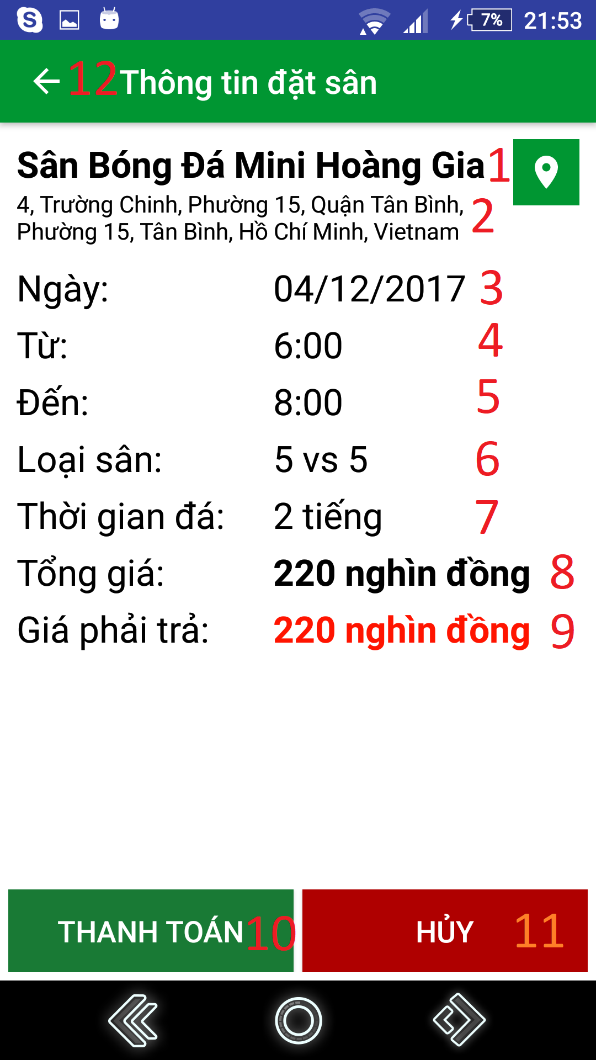

**Figure 104 - View Reservation Details UI**

**Fields**

|  |  |  |  |  |  |  |
| --- | --- | --- | --- | --- | --- | --- |
| **No** | **Field Names** | **Description** | **Read Only** | **Mandatory** | **Control Type** | **Data Type** |
| 1 | fieldName | Field’s name | Yes | Yes | TextView | String |
| 2 | fieldAddress | Field’s address | Yes | Yes | TextView | String |
| 3 | date | Reserved date | Yes | Yes | TextView | String |
| 4 | startTime | Start time | Yes | Yes | TextView | String |
| 5 | endTime | End time | Yes | Yes | TextView | String |
| 6 | fieldType | Field’s type | Yes | Yes | TextView | String |
| 7 | duration | Duration of match | Yes | Yes | TextView | String |
| 8 | totalPrice | Total price for the reservation | Yes | Yes | TextView | String |
| 9 | paidPrice | The price user must pay | Yes | Yes | TextView | String |

**Table 65 - <Mobile Application> View Reservation Details Fields**

**Buttons/Hyperlinks**

|  |  |  |  |  |
| --- | --- | --- | --- | --- |
| **No** | **Function** | **Description** | **Validation** | **Outcome** |
| 10 | Reserve | Reserve field | N/A | Show reservation result view |
| 11 | Cancel | Cancel reservation | N/A | Redirect to choose field’s free time view |
| 12 | goBack | Go back to previous view | N/A | Show previous view |

**Table 66 - <Mobile Application > View Reservation Details Buttons/Hyperlinks**

#### 5.1.7 Find Opponent

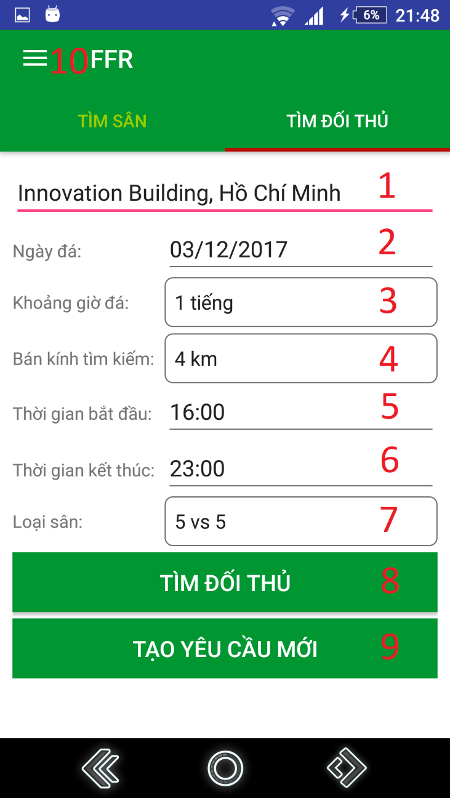

**Figure 105 – Find opponent UI**

**Fields**

|  |  |  |  |  |  |  |
| --- | --- | --- | --- | --- | --- | --- |
| **No** | **Field Names** | **Description** | **Read Only** | **Mandatory** | **Control Type** | **Data Type** |
| 1 | address | Input address where user wants to play | No | Yes | EditText | String |
| 2 | date | Choose date to reserve | No | Yes | Dropdown box | String |
| 3 | duration | Input duration | No | Yes | Spinner | String |
| 4 | distance | Input maximum distance for searching opponent | No | Yes | Spinner | String |
| 5 | startTime | Input start time for searching | No | Yes | EditText | String |
| 6 | endTime | Input end time for searching | No | Yes | EditText | String |
| 7 | fieldType | Field’s type | No | Yes | Dropdown box | String |

**Table 67 - <Mobile Application> Find opponent Fields**

**Buttons/Hyperlinks:**

|  |  |  |  |  |
| --- | --- | --- | --- | --- |
| **No** | **Function** | **Description** | **Validation** | **Outcome** |
| 8 | findOpponent | Find opponent | All fields required before summit | Show find opponent result view |
| 9 | createNewRequest | Create new request | All fields required before summit | Show create new request result view |
| 10 | showNavigation | Show navigation view | N/A | Show navigation bar |

**Table 68 - <Mobile Application> Find opponent Buttons/Hyperlinks**

#### 5.1.8 Matching Result

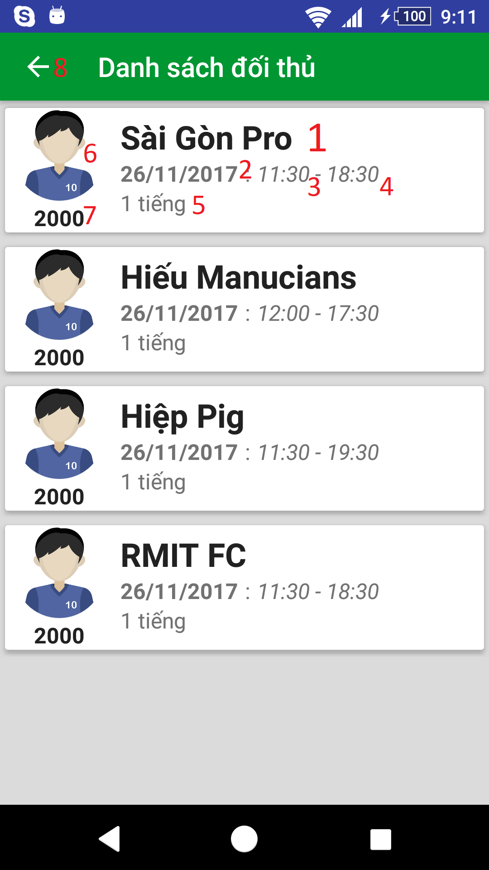

**Figure 105 – Matching result UI**

**Fields**

|  |  |  |  |  |  |  |
| --- | --- | --- | --- | --- | --- | --- |
| **No** | **Field Names** | **Description** | **Read Only** | **Mandatory** | **Control Type** | **Data Type** |
| 1 | teamName | User’s team name | Yes | Yes | TextView | String |
| 2 | date | Date | Yes | Yes | TextView | String |
| 3 | startTime | Start time | Yes | Yes | TextView | String |
| 4 | endTime | End time | Yes | Yes | TextView | String |
| 5 | duration | Duration | Yes | Yes | TextView | String |
| 6 | avatar | User’s avatar | Yes | Yes | ImageView | N/A |
| 7 | ratingScore | User’s rating score for ranking | Yes | Yes | TextView | String |

**Table 69 - <Mobile Application> Matching result Fields**

**Buttons/Hyperlinks:**

|  |  |  |  |  |
| --- | --- | --- | --- | --- |
| **No** | **Function** | **Description** | **Validation** | **Outcome** |
| 8 | goBack | Go back to previous view | N/A | Show previous view |

**Table 70 - <Mobile Application> Matching result Buttons/Hyperlinks**

#### 5.1.9 Deposit

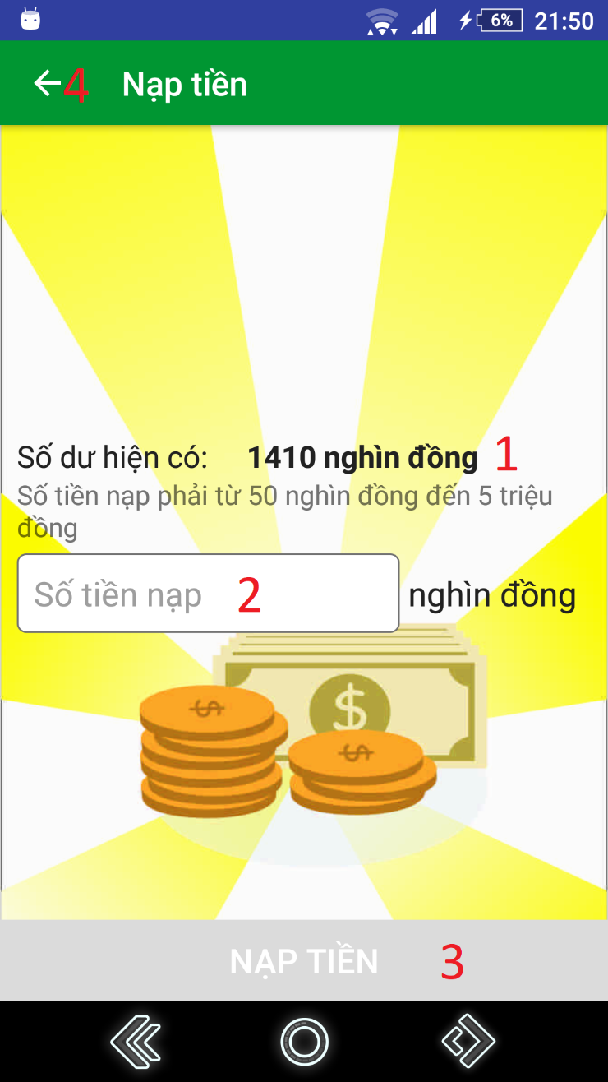

**Figure 105 – Recharge UI**

**Fields**

|  |  |  |  |  |  |  |
| --- | --- | --- | --- | --- | --- | --- |
| **No** | **Field Names** | **Description** | **Read Only** | **Mandatory** | **Control Type** | **Data Type** |
| 1 | balance | User’s current balance | Yes | Yes | TextView | String |
| 2 | rechargeMoney | Fill amount of money user wants to recharge | No | Yes | EditText | Integer |

**Table 71 - <Mobile Application> Deposit Fields**

**Buttons/Hyperlinks:**

|  |  |  |  |  |
| --- | --- | --- | --- | --- |
| **No** | **Function** | **Description** | **Validation** | **Outcome** |
| 3 | createNewRequest | Create new request | All fields required before summit | Show create new request result view |
| 4 | goBack | Go back to previous view | N/A | Show previous view |

**Table 72 - <Mobile Application> Deposit Buttons/Hyperlinks**

#### 5.1.10 Get reserved matches

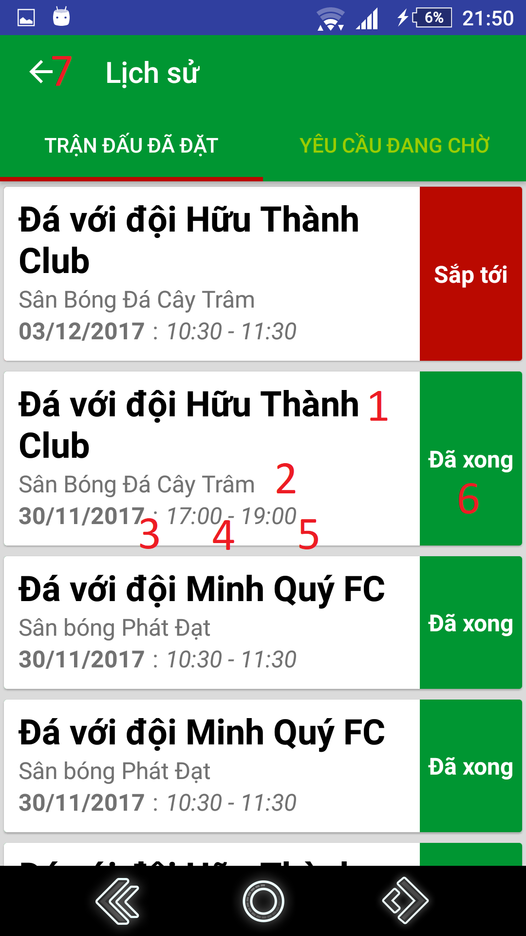

**Figure 105 – Get reserved matches UI**

**Fields**

|  |  |  |  |  |  |  |
| --- | --- | --- | --- | --- | --- | --- |
| **No** | **Field Names** | **Description** | **Read Only** | **Mandatory** | **Control Type** | **Data Type** |
| 1 | matchInfo | Information about match’s type and opponent’s team name played with (if have) | Yes | Yes | TextView | String |
| 2 | fieldName | Field name | Yes | Yes | TextView | String |
| 3 | date | Date | Yes | Yes | TextView | String |
| 4 | startTime | Start time | Yes | Yes | TextView | String |
| 5 | endTime | End time | Yes | Yes | TextView | String |
| 6 | status | Match’s status | Yes | Yes | TextView | String |

**Table 73 - <Mobile Application> Get reserved matches Fields**

**Buttons/Hyperlinks:**

|  |  |  |  |  |
| --- | --- | --- | --- | --- |
| **No** | **Function** | **Description** | **Validation** | **Outcome** |
| 7 | goBack | Go back to previous view | N/A | Show previous view |

**Table 74 - <Mobile Application> Get reserved matches Buttons/Hyperlinks**

#### 5.1.11 Get matching request

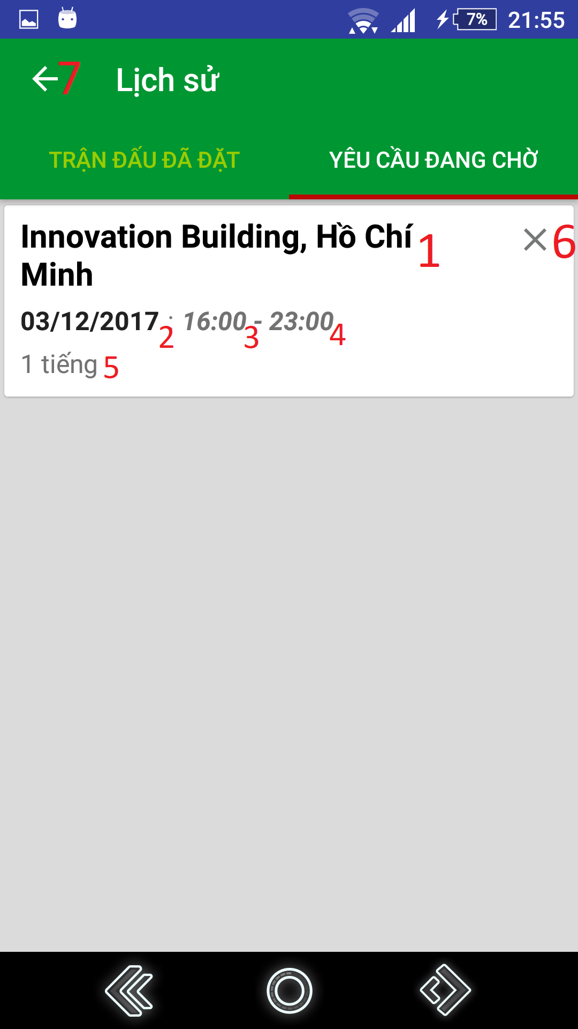

**Figure 105 – Get pending requests UI**

**Fields**

|  |  |  |  |  |  |  |
| --- | --- | --- | --- | --- | --- | --- |
| **No** | **Field Names** | **Description** | **Read Only** | **Mandatory** | **Control Type** | **Data Type** |
| 1 | address | Address where user create requests | Yes | Yes | TextView | String |
| 2 | date | Date | Yes | Yes | TextView | String |
| 3 | startTime | Start time | Yes | Yes | TextView | String |
| 4 | endTime | End time | Yes | Yes | TextView | String |
| 5 | duration | Duration | Yes | Yes | TextView | String |

**Table 75 - <Mobile Application> Get pending requests Fields**

**Buttons/Hyperlinks:**

|  |  |  |  |  |
| --- | --- | --- | --- | --- |
| **No** | **Function** | **Description** | **Validation** | **Outcome** |
| 6 | cancelRequest | Cancel Request | N/A | Refresh view pending matches view |
| 7 | goBack | Go back to previous view | N/A | Show previous view |

**Table 76 - <Mobile Application> Get pending requests Buttons/Hyperlinks**

#### 5.1.12 Rate field

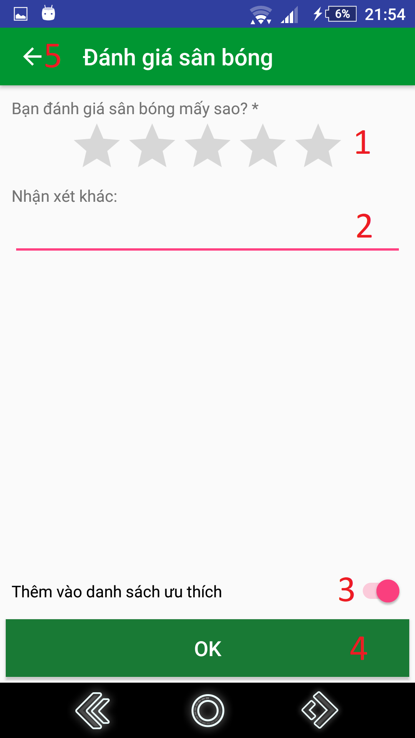

**Figure 105 – Rate field UI**

**Fields**

|  |  |  |  |  |  |  |
| --- | --- | --- | --- | --- | --- | --- |
| **No** | **Field Names** | **Description** | **Read Only** | **Mandatory** | **Control Type** | **Data Type** |
| 1 | ratingScore | Input user’s rating score about field’s quality | No | Yes | RatingBar | Float |
| 2 | comments | Input comments | No | No | EditText | String |

**Table 77 - <Mobile Application> Rate field Fields**

**Buttons/Hyperlinks:**

|  |  |  |  |  |
| --- | --- | --- | --- | --- |
| **No** | **Function** | **Description** | **Validation** | **Outcome** |
| 3 | setFavorite | Add/remove field to/from favorite list | All fields required before summit | Show setting result message. |
| 4 | submitRating | Submit field rating | All fields required before summit | Show submit rating result message. |
| 5 | goBack | Go back to previous view | N/A | Show previous view |

**Table 78 - <Mobile Application> Rate field Buttons/Hyperlinks**

#### 5.1.13 Rate opponent

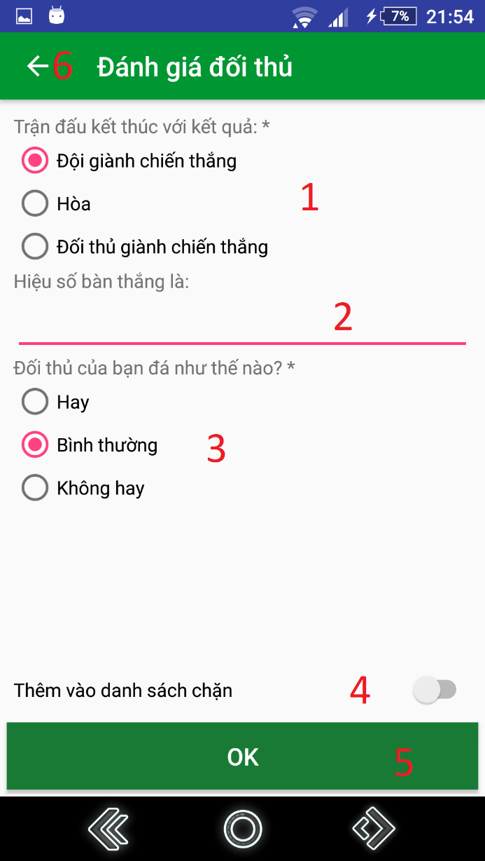

**Figure 105 – Rate opponent UI**

**Fields**

|  |  |  |  |  |  |  |
| --- | --- | --- | --- | --- | --- | --- |
| **No** | **Field Names** | **Description** | **Read Only** | **Mandatory** | **Control Type** | **Data Type** |
| 1 | winner | Input the match result | No | Yes | RadioButton | String |
| 2 | goalDifference | Input the match’s goal difference | No | No | EditText | Integer |
| 3 | opponentSkill | Input opponent’s performance in the match | No | Yes | RadioButton | String |

**Table 79 - <Mobile Application> Rate opponent Fields**

**Buttons/Hyperlinks:**

|  |  |  |  |  |
| --- | --- | --- | --- | --- |
| **No** | **Function** | **Description** | **Validation** | **Outcome** |
| 4 | setBlacklist | Add opponent to blacklist | All fields required before summit | Show setting result message. |
| 5 | submitRating | Submit opponent rating | All fields required before summit | Show submit rating result message. |
| 6 | goBack | Go back to previous view | N/A | Show previous view |

**Table 80 - <Mobile Application> Rate opponent Buttons/Hyperlinks**

#### 5.1.14 Report opponent

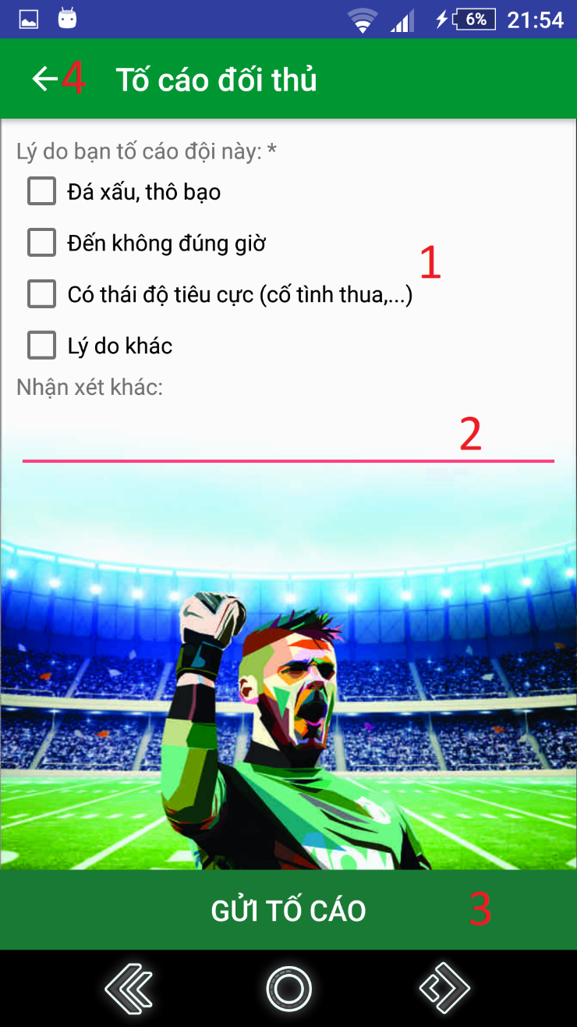

**Figure 105 – Report opponent UI**

**Fields**

|  |  |  |  |  |  |  |
| --- | --- | --- | --- | --- | --- | --- |
| **No** | **Field Names** | **Description** | **Read Only** | **Mandatory** | **Control Type** | **Data Type** |
| 1 | presetReasons | Input report reasons. | No | Yes | CheckBox | String |
| 2 | comments | Input comments. | No | No | EditText | String |

**Table 81 - <Mobile Application> Report opponent Fields**

**Buttons/Hyperlinks:**

|  |  |  |  |  |
| --- | --- | --- | --- | --- |
| **No** | **Function** | **Description** | **Validation** | **Outcome** |
| 3 | submitReport | Submit opponent report | All fields required before summit | Show submit report result message. |
| 4 | goBack | Go back to previous view | N/A | Show previous view |

**Table 82 - <Mobile Application> Report opponent Buttons/Hyperlinks**

### Web application

#### Login

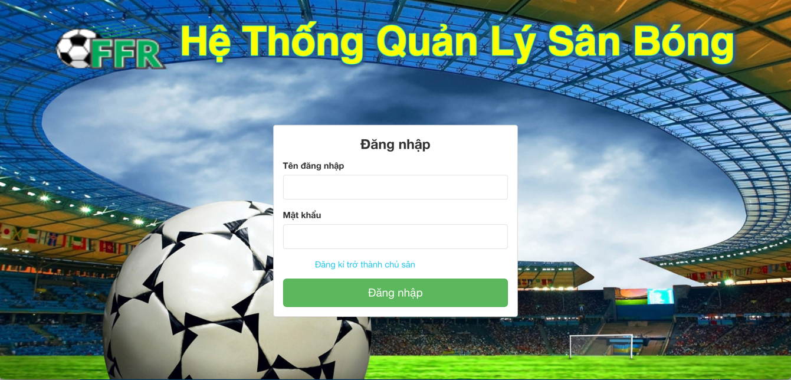

Figure 1 - Login UI

**Fields**

|  |  |  |  |  |  |  |
| --- | --- | --- | --- | --- | --- | --- |
| **No** | **Field Names** | **Description** | **Read Only** | **Mandatory** | **Control Type** | **Data Type** |
| 1 | Username | Fill Username | No | Yes | Textbox | String |
| 2 | Password | Fill Password | No | Yes | Password | String |

Table 1 - <Web Application> Login Fields

**Buttons/Hyperlinks**

|  |  |  |  |  |
| --- | --- | --- | --- | --- |
| **No** | **Function** | **Description** | **Validation** | **Outcome** |
| 3 | Login | Login into system | All fields required before summit | Redirect to manage account page/Field Owner Index page/Lock account based on role. |

**Table 2 - <Web Application > Login Buttons/Hyperlinks**

#### Get Matches By Date

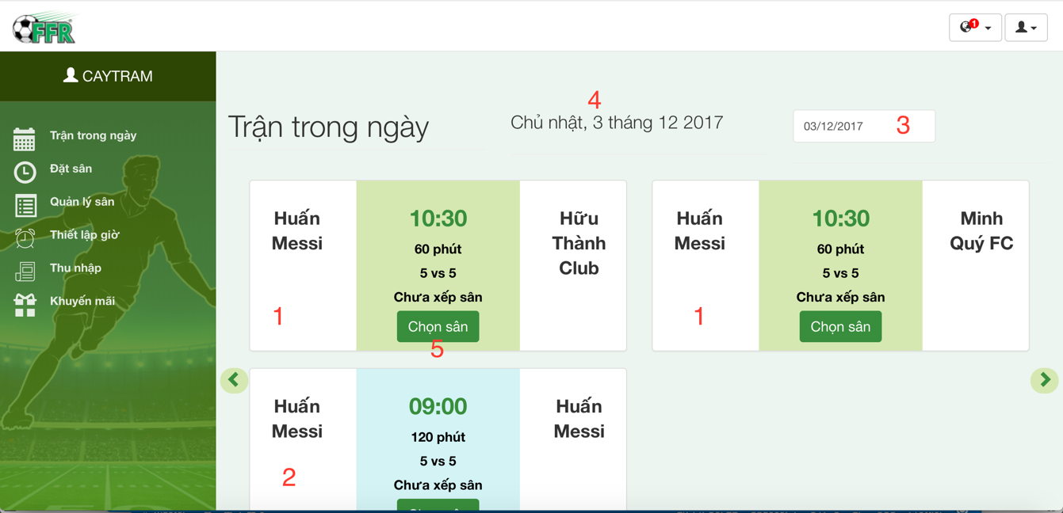

Figure 2 – Get Matches by date

**Fields**

|  |  |  |  |  |  |  |
| --- | --- | --- | --- | --- | --- | --- |
| **No** | **Field Names** | **Description** | **Read Only** | **Mandatory** | **Control Type** | **Data Type** |
| 1 | TourMatch  Data | The system matches two user | Yes | No | Text | String |
| 2 | FriendlyMatch  Data | User reserve match | Yes | No | Text | String |
| 4 | Current Date Format | Show date chosen | Yes | No | Text | String |

Table 3 - <Web Application> Get match by date

**Buttons/Hyperlinks**

|  |  |  |  |  |
| --- | --- | --- | --- | --- |
| **No** | **Function** | **Description** | **Validation** | **Outcome** |
| 3 | ChooseDate | Select target date | N/A | Date selected |

Table 4 - <Web Application> Get Matches By Date Buttons/Hyperlinks

#### Choose Field For Match

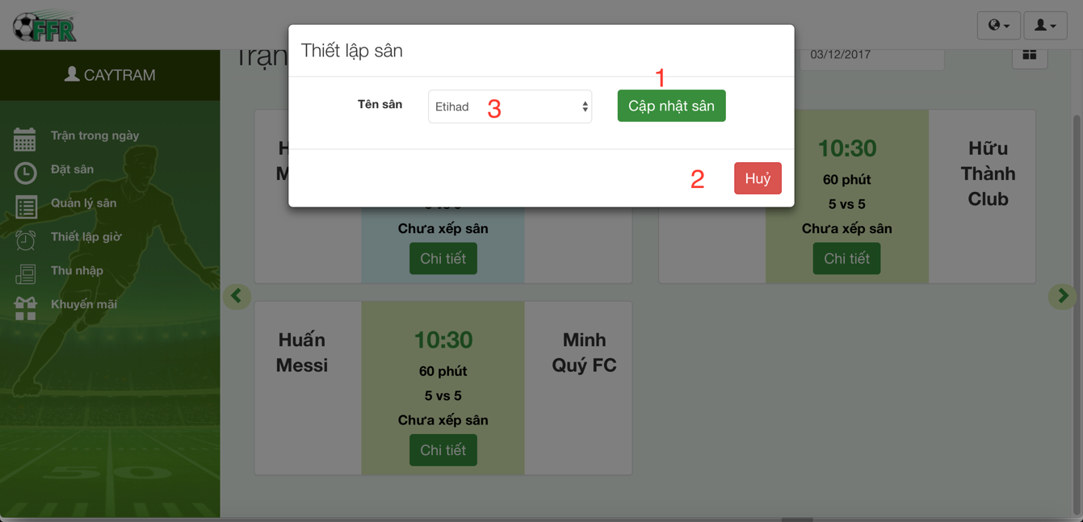

Figure 3 – Choose field for match UI

**Fields**

|  |  |  |  |  |  |  |
| --- | --- | --- | --- | --- | --- | --- |
| **No** | **Field Names** | **Description** | **Read Only** | **Mandatory** | **Control Type** | **Data Type** |
| 3 | FieldName | Name of a field | No | Yes | Dropbox | String |

Table 5 - <Web Application> Set Field For Match

**Buttons/Hyperlinks**

|  |  |  |  |  |
| --- | --- | --- | --- | --- |
| **No** | **Function** | **Description** | **Validation** | **Outcome** |
| 1 | UpdateField  ForMatch | Update a field to a match | N/A | Set field for a match |
| 2 | Cancel | Cancel action set field to match | N/A | Back to field owner index page |

**Table 6 - <Web Application > Set Field For Match Buttons/Hyperlinks**

#### Update Time Available

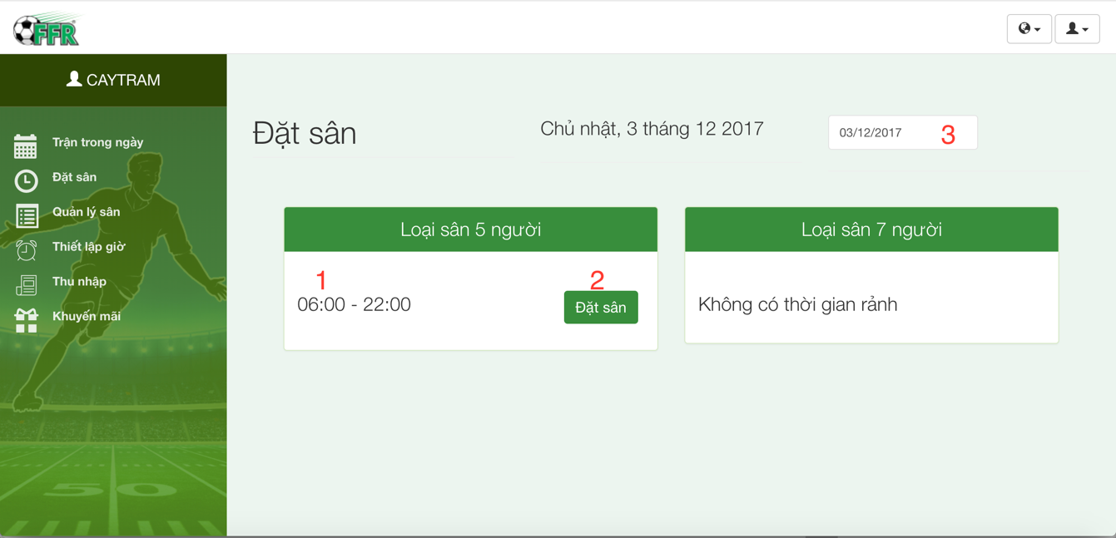Figure 4 – Update time available UI

**Fields:**

|  |  |  |  |  |  |  |
| --- | --- | --- | --- | --- | --- | --- |
| **No** | **Field Names** | **Description** | **Read Only** | **Mandatory** | **Control Type** | **Data Type** |
| 1 | Time | Time enable to update | Yes | Yes | Text | String |

Table 7 - <Web Application> Update Time Available

**Buttons/Hyperlinks**

|  |  |  |  |  |
| --- | --- | --- | --- | --- |
| **No** | **Function** | **Description** | **Validation** | **Outcome** |
| 2 | UpdateTimeAvailable | Update time available of field | N/A | Time available is updated |
| 3 | Date | Tagert date | N/A | Date selected |

Table 8 - <Web Application> Deactivate Account Buttons/Hyperlinks

#### Field Management

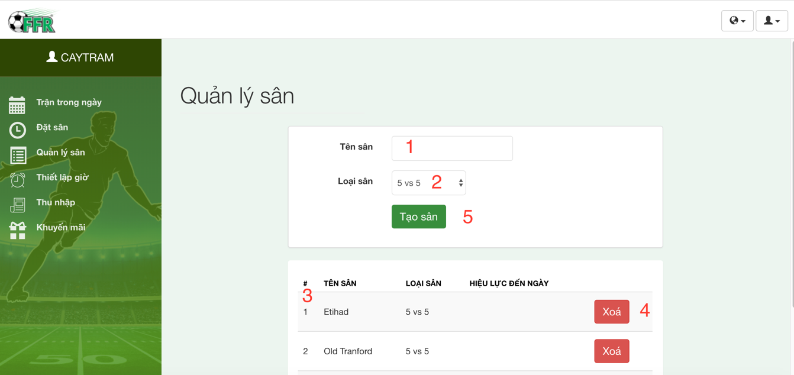

Figure 5 – Manage Field UI

**Fields:**

|  |  |  |  |  |  |  |
| --- | --- | --- | --- | --- | --- | --- |
| **No** | **Field Names** | **Description** | **Read Only** | **Mandatory** | **Control Type** | **Data Type** |
| 1 | FieldName | Name of field | No | Yes | Textbox | String |
| 2 | FieldType | Name of field type | No | Yes | Dropbox | String |
| 3 | DataField | Show all field | Yes | Yes | Table | String |

Table 9 - <Web Application> Fied Management

**Buttons/Hyperlinks**

|  |  |  |  |  |
| --- | --- | --- | --- | --- |
| **No** | **Function** | **Description** | **Validation** | **Outcome** |
| 4 | Delete Field | Delete field | N/A | Delete a field |
| 5 | Create Field | Create a new field | N/A | Create new field |

Table 10 - <Web Application> Fied Management Buttons/Hyperlinks

#### Manage Active Time

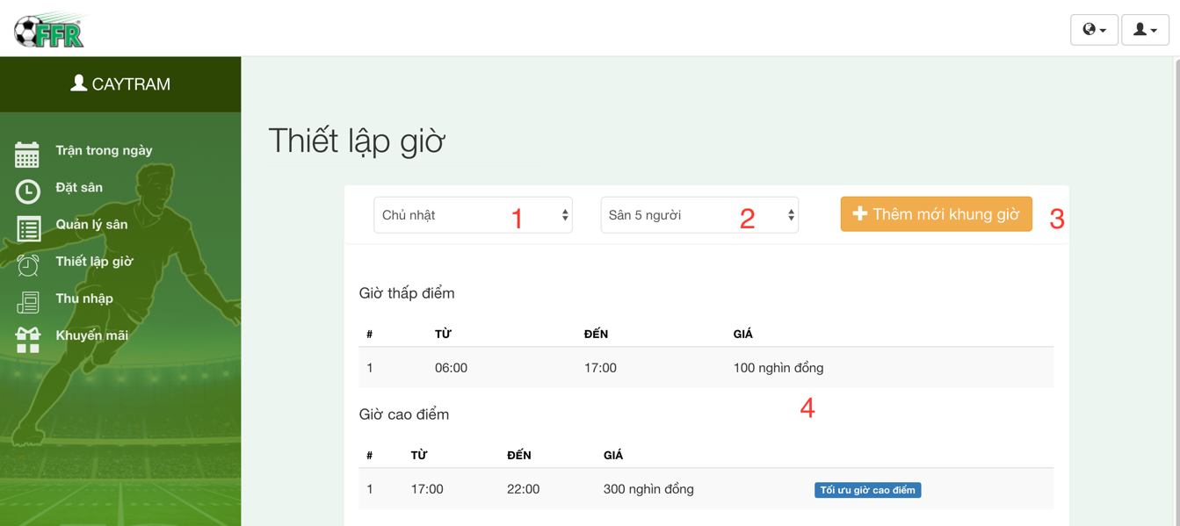

Figure 6 - Update Time Enable UI

**Fields**

|  |  |  |  |  |  |  |
| --- | --- | --- | --- | --- | --- | --- |
| **No** | **Field Names** | **Description** | **Read Only** | **Mandatory** | **Control Type** | **Data Type** |
| 1 | DayInWeek | Day In week | No | Yes | Dropbox | String |
| 2 | FieldType | Type of field | No | Yes | Dropbox | String |
| 4 | Active  TimeData | Set active time for field | No | Yes | Table | String |

Table 11 - <Web Application> Manage active time

**Buttons/Hyperlinks**

|  |  |  |  |  |
| --- | --- | --- | --- | --- |
| **No** | **Function** | **Description** | **Validation** | **Outcome** |
| 3 | Update active time | Open popup to update new active time | N/A | Open popup |

Table 12 - <Web Application> Manage active time Buttons/Hyperlinks

#### Update Active Time Management

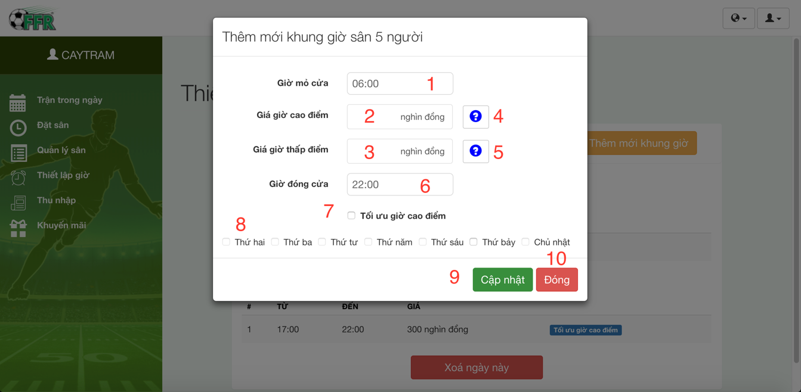

Figure 7 – Update active time UI

**Fields**

|  |  |  |  |  |  |  |
| --- | --- | --- | --- | --- | --- | --- |
| **No** | **Field Names** | **Description** | **Read Only** | **Mandatory** | **Control Type** | **Data Type** |
| 1 | StartTime | Opening time | No | Yes | Dropbox | DateTime |
| 2 | Peakhourprice | Peak hour price | No | Yes | Textbox | Float |
| 3 | IdleHourPrice | Idle hour price | No | Yes | Textbox | Float |
| 6 | CloseTime | Closing time | No | Yes | Dropbox | DateTime |
| 7 | IsEnableOptimize | Optimize peak time | No | No | Checkbox | Boolean |
| 8 | DayInWeek | Day in week | No | Yes | Checkbox | Boolean |

Table 13 - <Web Application> Update active time

**Buttons/Hyperlinks**

|  |  |  |  |  |
| --- | --- | --- | --- | --- |
| **No** | **Function** | **Description** | **Validation** | **Outcome** |
| 4 | GetDetailPeakHour | Show detail peak hour | N/A | Show tooltip |
| 5 | GetDetailIdleHour | Show detail idle hour | N/A | Show tooltip |
| 9 | UpdateActiveTime |  | N/A |  |
| 10 | Cancel | Close popup | N/A | Close popup |

Table 14 - <Web Application> Update active time

#### Income Management

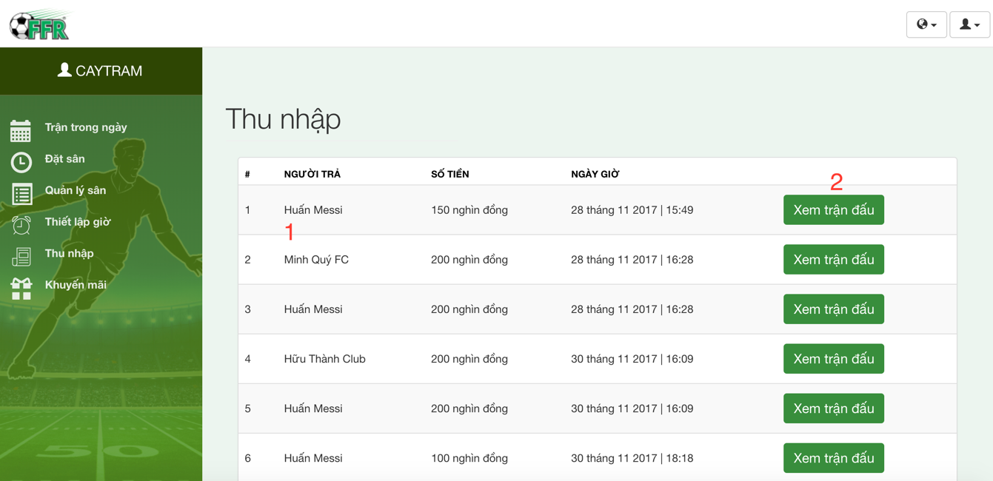

Figure 8 – Manage Income UI

**Fields:**

|  |  |  |  |  |  |  |
| --- | --- | --- | --- | --- | --- | --- |
| **No** | **Field Names** | **Description** | **Read Only** | **Mandatory** | **Control Type** | **Data Type** |
| 1 | Incomedata | Income data | Yes | No | Table | String |

Table 15 - <Web Application> Manage Income

**Buttons/Hyperlinks**

|  |  |  |  |  |
| --- | --- | --- | --- | --- |
| **No** | **Function** | **Description** | **Validation** | **Outcome** |
| 2 | ViewDetailBill | View detail a bill | N/A | Open popup |

**Table 16 - <Web Application> Manage Income Buttons/Hyperlinks**

#### Promotion Management

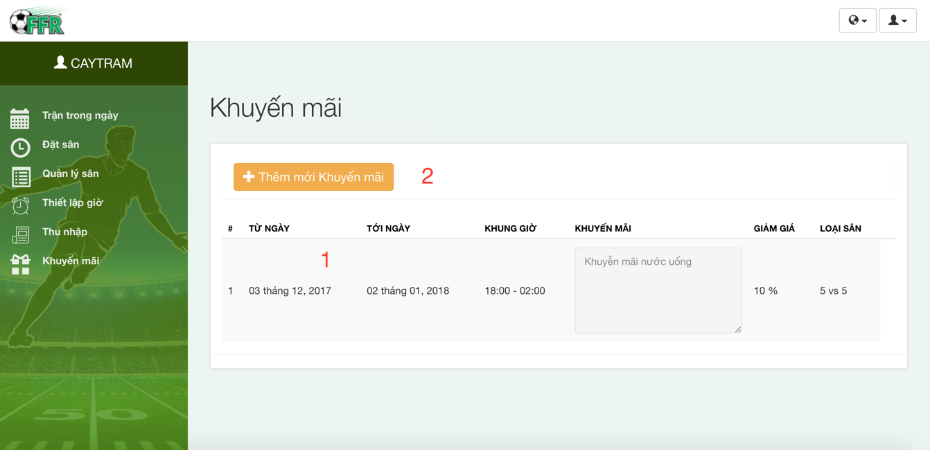

Figure 9 – Promotion Management UI

**Fields**

|  |  |  |  |  |  |  |
| --- | --- | --- | --- | --- | --- | --- |
| **No** | **Field Names** | **Description** | **Read Only** | **Mandatory** | **Control Type** | **Data Type** |
| 1 | PromotionData | Promotion data | Yes | No | Table | String |

Table 17 - <Web Application> Promotion Management Fields

**Buttons/Hyperlinks**

| **No** | **Function** | **Description** | **Validation** | **Outcome** |
| --- | --- | --- | --- | --- |
| 2 | AddNewPromotion | Add new promotion | N/A | Open popup |

Table 18 - <Web Application> Promotion Management Buttons/Hyperlinks

#### 5.2.10 Add promotion

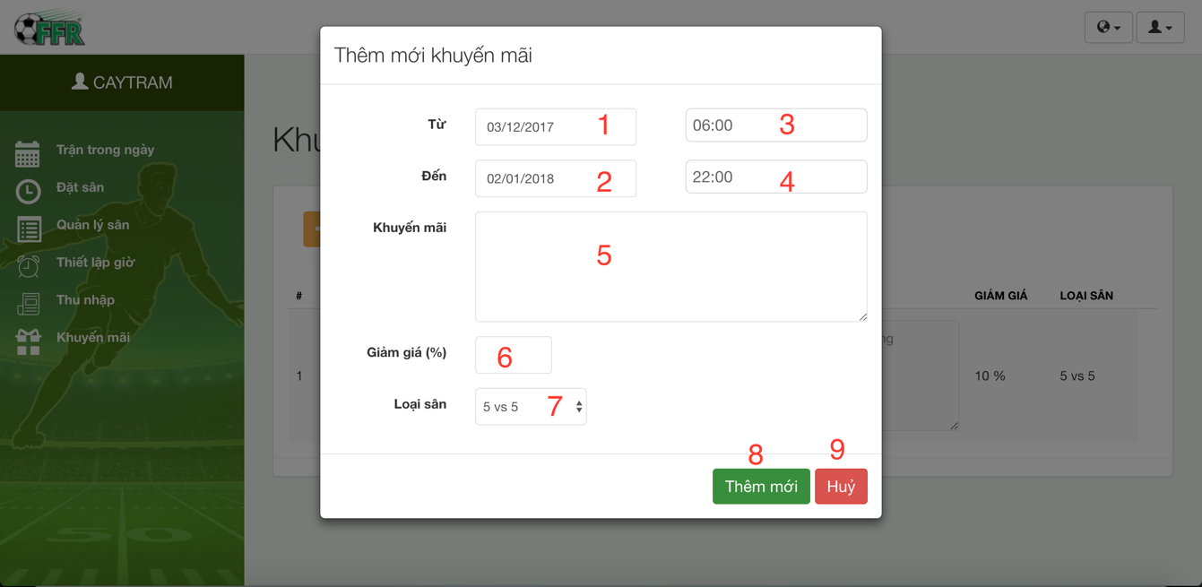

**Figure 10 - Add Promotion UI**

**Fields**

|  |  |  |  |  |  |  |
| --- | --- | --- | --- | --- | --- | --- |
| **No** | **Field Names** | **Description** | **Read Only** | **Mandatory** | **Control Type** | **Data Type** |
| 1 | Startdate | Start Date promotion | No | Yes | Date Picker | Date |
| 2 | EndDate | End Date promotion | No | Yes | Date Picker | Date |
| 3 | StartTime | Start time promotion | No | Yes | Dropbox | DateTime |
| 4 | EndTime | End Time promotion | No | Yes | Dropbox | DateTime |
| 5 | Description | Promotion description | No | Yes | TextArea | String |
| 6 | DiscountPercent | Promotion discount percent | No | Yes | Textbox | Float |
| 7 | FieldType | Field type to promote | No | Yes | Dropbox | String |

**Table 19 - <Web Application> Add Promotion**

**Buttons/Hyperlinks**

|  |  |  |  |  |
| --- | --- | --- | --- | --- |
| **No** | **Function** | **Description** | **Validation** | **Outcome** |
| 8 | AddNewPromotion | Add new promotion | N/A | Close popup, show notify. |
| 9 | Cancel | Close popu[ | N/A | Close popup |

**Table 20 - <Web Application> Add Promotion Buttons/Hyperlinks**

#### 5.2.11 User Management

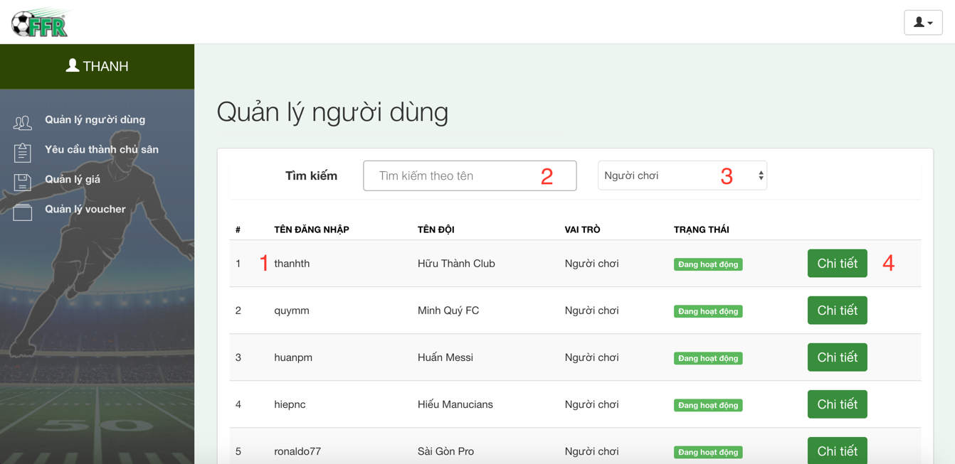

**Figure 11 – User Management UI**

**Fields**

|  |  |  |  |  |  |  |
| --- | --- | --- | --- | --- | --- | --- |
| **No** | **Field Names** | **Description** | **Read Only** | **Mandatory** | **Control Type** | **Data Type** |
| 1 | UserData | User data | Yes | No | Table | String |
| 2 | SearchByUsername | Search User | No | Yes | Textbox | String |
| 3 | TypeUserTarget | User target to search | No | Yes | Dropbox | String |

**Table 21 - <Web Application> User Management**

**Buttons/Hyperlinks**

|  |  |  |  |  |
| --- | --- | --- | --- | --- |
| **No** | **Function** | **Description** | **Validation** | **Outcome** |
| 4 | ShowDetailUser | Show popup to view detail user | N/A | Open popup |

**Table 22 - <Web Application> User Management Buttons/Hyperlinks**

#### 5.2.12 View User Details

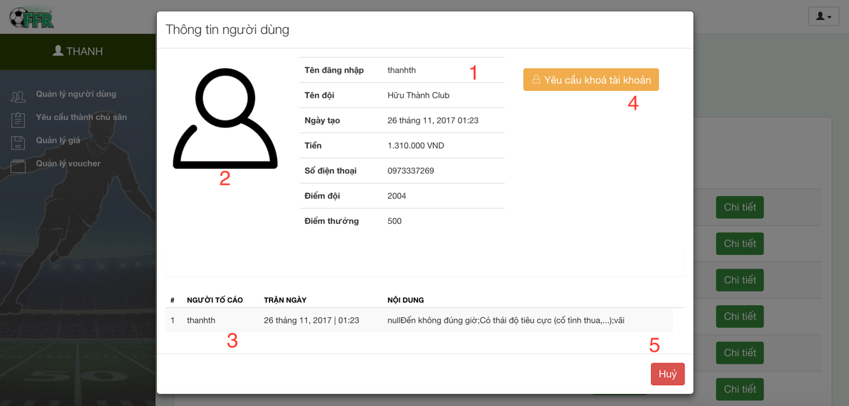

**Figure 12 - View User Details UI**

**Fields**

|  |  |  |  |  |  |  |
| --- | --- | --- | --- | --- | --- | --- |
| **No** | **Field Names** | **Description** | **Read Only** | **Mandatory** | **Control Type** | **Data Type** |
| 1 | UserInfomaion | Information of user | Yes | No | Table | String |
| 2 | UserImage | Image of user | Yes | No | Image | Image |
| 3 | Reported data | Reports of user | Yes | No | Table | String |

**Table 23 - <Web Application> View User Details**

**Buttons/Hyperlinks**

|  |  |  |  |  |
| --- | --- | --- | --- | --- |
| **No** | **Function** | **Description** | **Validation** | **Outcome** |
| 4 | RequestToLock | Request to lock user | N/A | Show message request lock. |
| 5 | Cancel | Close popup | N/A | Close popup |

**Table 24 - <Web Application> View User Details Buttons/Hyperlinks**

#### 5.2.13 Lock User

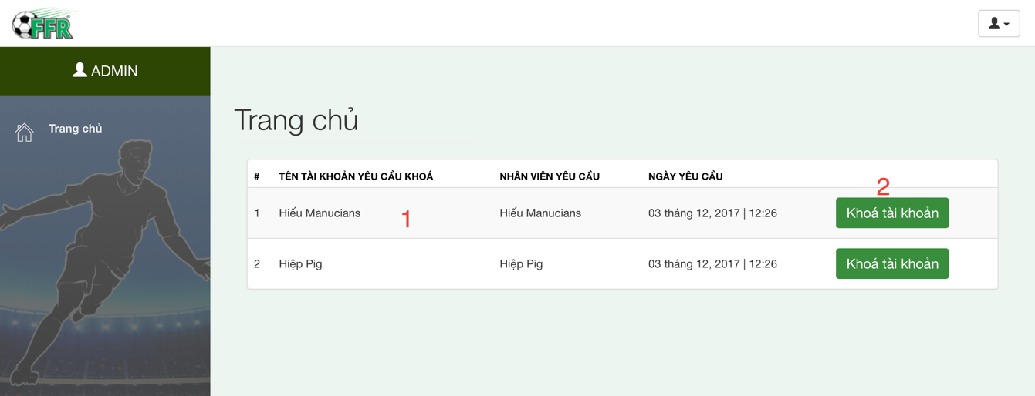

**Figure 13 – Lock User UI**

**Fields**

|  |  |  |  |  |  |  |
| --- | --- | --- | --- | --- | --- | --- |
| **No** | **Field Names** | **Description** | **Read Only** | **Mandatory** | **Control Type** | **Data Type** |
| 1 | UserRequestedToLock | The user was requested to lock | Yes | No | Table | String |

**Table 25 - <Web Application> Lock User**

**Buttons/Hyperlinks**

| **No** | **Function** | **Description** | **Validation** | **Outcome** |
| --- | --- | --- | --- | --- |
| 2 | LockAccount | Show popup do confirm lock | N/A | Open popup confirm |

**Table 26 - <Web Application> Relation Product Buttons/Hyperlinks**

#### 5.2.14 Confirm Lock Account

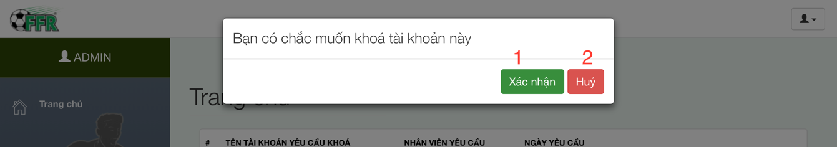

**Figure 14 – Confirm Lock Account UI**

**Fields:** N/A

**Buttons/Hyperlinks**

|  |  |  |  |  |
| --- | --- | --- | --- | --- |
| **No** | **Function** | **Description** | **Validation** | **Outcome** |
| 1 | ConfirmLock | Confirm lock account | N/A | Show message lock |
| 2 | Cancel | Close popup | N/A | Close popup |

**Table 27 - <Web Application> Confirm Lock Account Buttons/Hyperlinks**